Control system
A control system consists of processes or systems (known as plants) assembled for the purpose of obtaining a desired output with desired performance, given a specified input.
The figure shows a control system in its simplest form. The input to the control system is the desired output in a suitable form. | 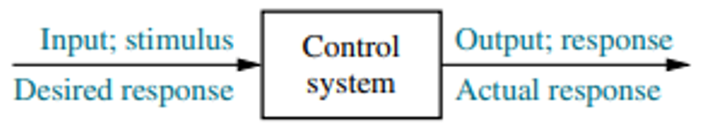
As an example consider the case of an elevator. When a person presses the tenth-floor button, the elevator rises to the tenth floor with a speed and floor levelling accuracy designed for the passenger comfort. The push of the tenth floor button is the input that represents the desired output. | 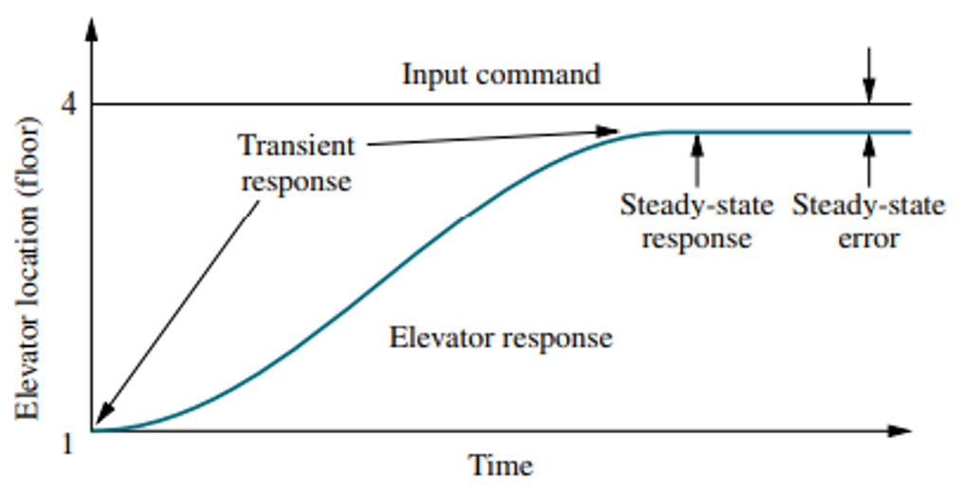  10
This input is shown as a step function in the figure. The performance of the elevator is also shown as repsonse curve along with the input. Two major measures of performance are i) the transient response and ii) the steady state error. In the elevator example, the passenger comfort and passenger patience are dependent on its transient response. If the response is too fast, passenger comfort is compromised; if too slow, passenger patience is compromised. The steady state response is also another important performance parameter. If the elevator does not stop properly at the tenth floor level, the safety and convenience of the passenger would be sacrificed.
The control system is built for four primary reasons:
- Power amplification 2. Remote control 3. Conveniene of input form
- Compensation for disturbances
For example, a radar antenna, positioned by the low power rotation of a knob at the input, requires a large amount of power for its output rotation. A control system can produce the needed power amplification, or power gain.
Control systems are also useful in remote or dangerous locations. For example, a remote-controlled robot arm can be used to pick up material in a radioactive environment.
Control systems can also be used to provide convenience by changing the form of the input. For example, in a temperature control system, the input is a position on a thermostat. The out put is heat. A convenient position input yields a desired heat output.
Another advantage of control system is the ability to compensate for disturbances. If the response of a system changes from its commanded input value due to disturbances or noise, the system must be able to detect the change and correct itself. The input will not change to make the correction. The system itself should measure the deviation and do the correction accordingly.

Open-Loop Systems  The figure shows an open-loop system. It consists of an input transducer, which converts the form of input to that used by the controller. | 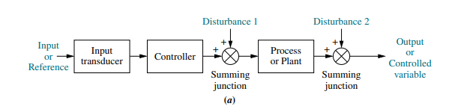
The controller drives the plant. The input is given as the reference or the desired output. The actual output is also called controlled variable. Other signals, such as disturbances, are added to the controller and process outputs via summing junctions. For example, the plant can be a furnace, where the output variable is temperature. The controller consists of fuel valves and the electrical system that operates the valves. Another example is the bread toaster. The disadvantage of open-loop system is its inability to correct for the disturbances.
Closed loop systems  The disadvantage of the open-loop system is overcome by the closed-loop system. The input transducer converts the form of input to the form used by the controller. | 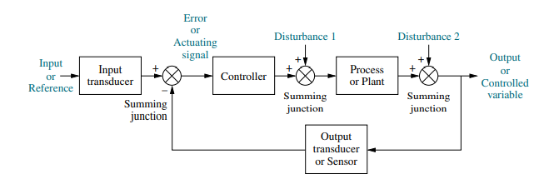
The output transducer, or sensor, measures the output response and converts it into the form used by the controller. For example, if the controller uses electrical signals to operate the valves of a temperature control system, the input position and the output temperature are converted to electrical signals. The input position can be converted to a voltage by a potentiometer, and the output temperature can be converted to a voltage by a thermistor, a device whose electrical resistance changes with temperature.
The first summing junction algebraically adds the signal from the input to the signal from the output, which arrives via the feedback path, the return path from the output to the summing junction. Here, in the figure the out put signal is subtracted from the input signal. The result is generally called the actuating signal or error signal.
The closed-loop system compensates for disturbances by measuring the output response, feeding that measurement back through a feed back path, and comparing that response to that input at the summing junction. | 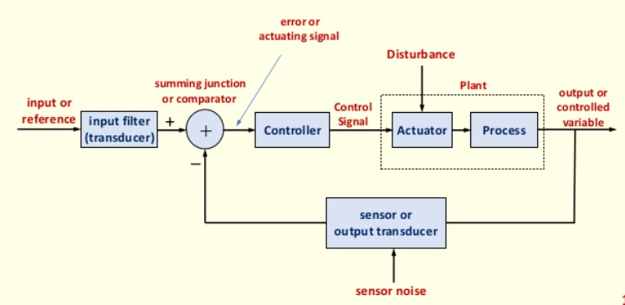
If there is any difference between the two responses, the system drives the plant, via the actuating signal to make a correction. If there is no difference, the system does not drive the plant, since the plant’s response is already the desired response.
- Closed-loop systems have the advantage of greater accuracy than open-loop systems.
- They are less sensitive to noise, disturbances, and changes in the environment.
- Transient response and steady-state error can be controlled more efficiently closed-loop system often by a simple adjustment of gain in the loop and sometimes by redesigning the controller. The redesign is known as compensating the system and to the resulting hardwae as a compensator.
- Closed-loop systems are more complex and expensive

Analysis & design
Analysis is the process by which a system’s performance is determined.
A control system is dynamic: It responds to an input by undergoing a transient response before reaching a steady-state response. Three major objectives in the analysis and design of systems are producing the desired transient response, reducing the stready state error, and achieving stability. Design is the process by which a system’s performance is created or changed.
Let us consider an example of the disk drive of a computer. Since reading and writing cannot take place until the head stops (transient response), the speed of the read/write head’s movement from one track on the disk to another influences the overall speed of the computer. The read/write head should be positioned over the commanded track without error (steady state response) | 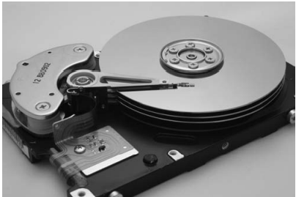

The Design Process
- Step 1: Transform requirements into a physical system
- Step 2: Draw a functional block diagram
- Step 3: Create a schematic
- Step 4: Develop a mathematical model (Block Diagram)
- Step 5: Reduce the block diagram
- Step 6: Analyse and design
Standard test input signals are used, both analytically and during testing, to verify the design. | Impulse | $$δ(t)$$  $$δ\left(t\right)=∞, 0^{-}<t< 0^{+}$$  $$=0, elsewhere$$ | 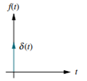 | Transient response modelling
 | Step | $u(t)$  $$u\left(t\right)=1, for t> 0$$  $$=0, elsewhere$$ | 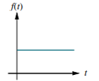 | Transient response, steady state error
 | Ramp | $tu(t)$  $$tu\left(t\right)=t, for t≥ 0$$  $$=0, elsewhere$$ | 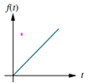 | steady state error
 | Parabola | $$\frac{1}{2}t^{2}u(t)$$  $$\frac{1}{2}t^{2}u\left(t\right)=\frac{1}{2}t^{2},for t≥ 0$$ | 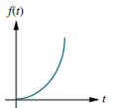 | steady state error
 | Sinusoid | $$\sin{ωt}$$ | 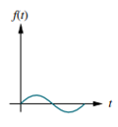 | Transient response, steady state error

Let us consider a few examples how to convert physical systems to block diagrams.
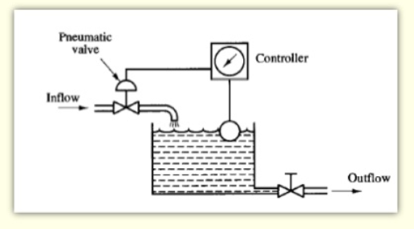 | 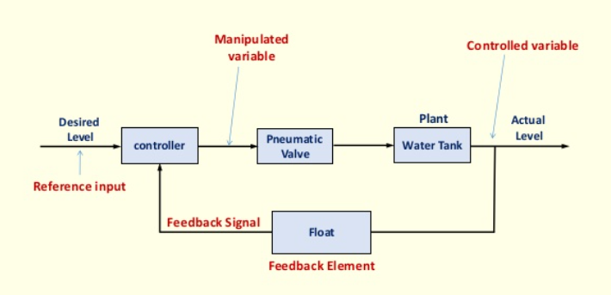

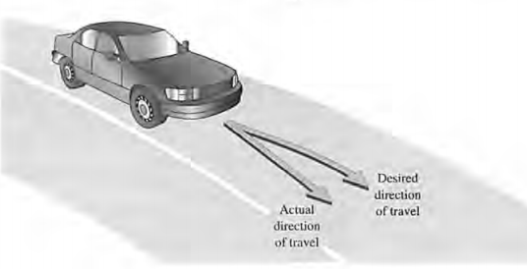 | 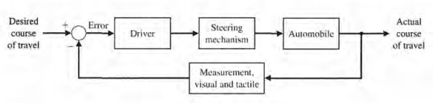

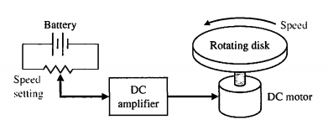 | 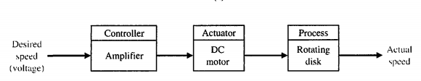

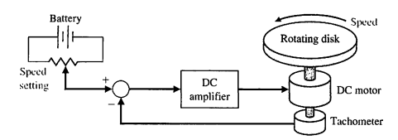 | 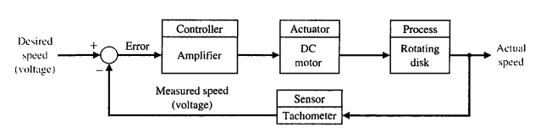

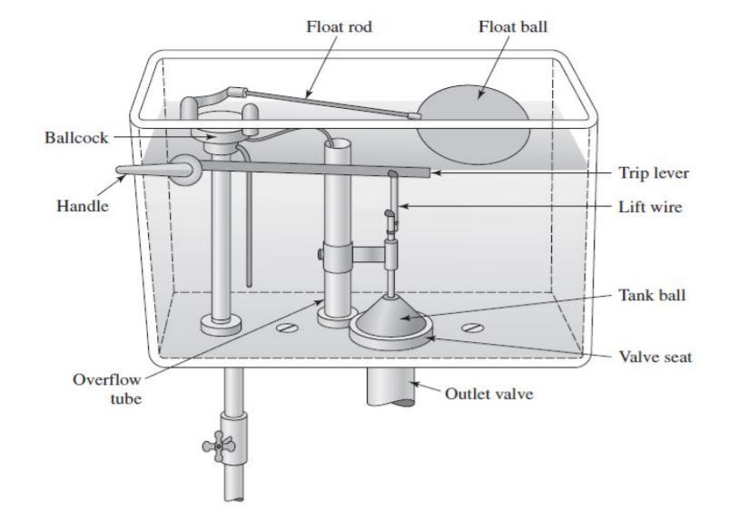 | 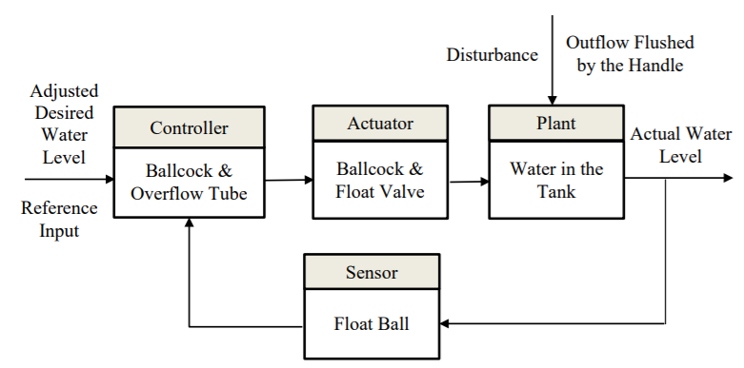

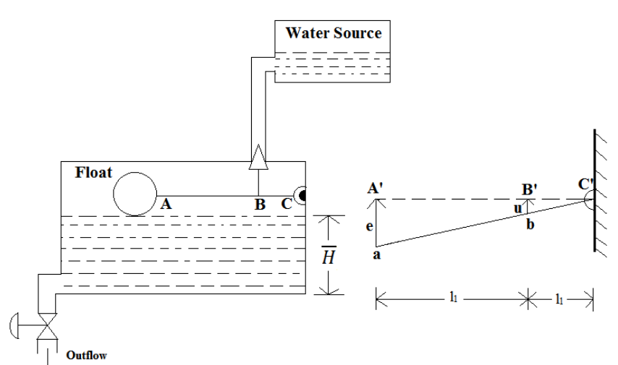 | 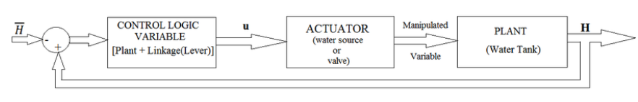

Human beings experience a fever (increase in body temperature) associated with illness. It is the outcome of governed by the thermostatic controller of the body. The increased activity of the hostile micro-organisms triggers the central nervous system to command an increase in the set point (i.e, reference input) of the thermostat, because it happens that the immune response of the body can be strengthened at a higher temprature. | 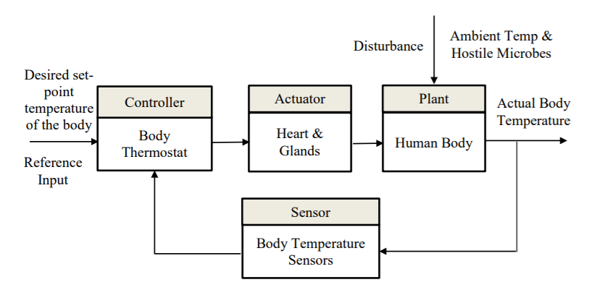

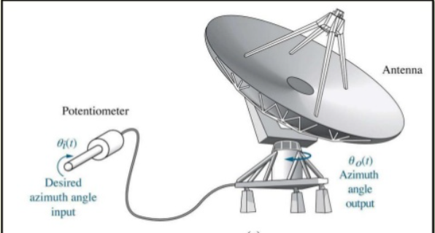 | 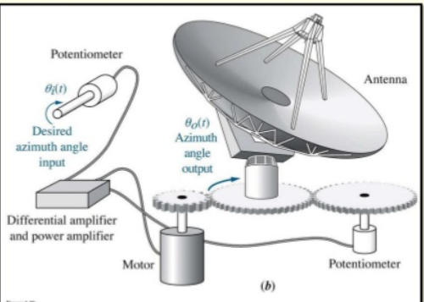

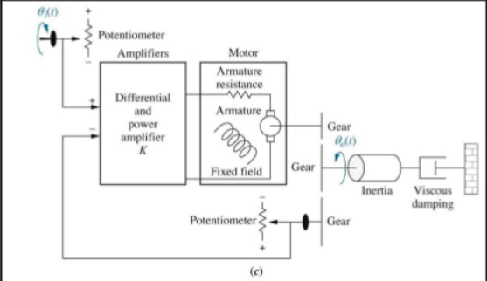 | 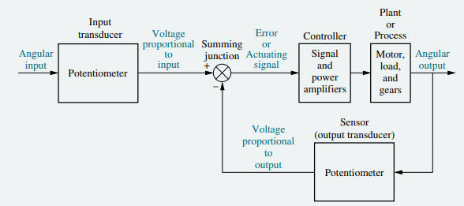

Exercise 1
A temperature control system operates by sensing the difference between the thermostat setting and the temperature and then opening a fuel valve an amount proportional to this difference. Draw a functional closed-loop block diagram indetifying the input and output transducers, the controller, and the plant.
Exercise 2  An aircaft’s attitude varies in roll, pitch, and yaw as defined in figure. Draw a functional block diagram for a closed-loop system that stabilizes the roll as follows: The system measures the actual roll angle with a gyro and compares the actual roll angle with the desired roll angle. The ailerons respond to the roll angle error by undergoing an angular deflection. The aircraft responds to this angular deflection, producing a roll angle rate. Identify the input and output transducers, the controller, and the plant. | 